STUDENT PERFORMANCE ANALYTICS SYSTEM
Python with AI – EWB Project
Submitted By:
Name: Mhaske Bhakti Pandurang
Class: Third Year B.E. IT
Department: Information Technology
College: Pravara Rural College Of Engineering
Technology Used: Python, NumPy, Pandas
Academic Year: 2026–27

1. OBJECTIVE
The objective of this project is to develop a Student Performance Analytics System using Python, NumPy, and Pandas.
The system analyzes student academic data and calculates total marks, average marks, grades, pass/fail results, class performance, subject-wise performance, attendance, and top-performing students.
The project demonstrates the practical use of Python programming concepts, NumPy numerical calculations, and Pandas DataFrame operations for data analysis.

2. TECHNOLOGIES USED
Programming Language
- Python – Used for developing the complete application and implementing the analysis logic.
Libraries
- Pandas – Used for loading, storing, filtering, sorting, and analyzing student data using DataFrames.
- NumPy – Used for numerical calculations such as average, minimum, and maximum values.
Data Storage
- CSV (Comma-Separated Values) – Used to store the student dataset.
Development Environment
- Visual Studio Code (VS Code) – Used for writing and executing the Python program.
Project Files
- main.py – Main program.
- functions.py – Contains reusable functions for grade, result, and performance-level calculations.
- students.csv – Student dataset.
- README.md – Project information and instructions.

3. DATASET DESCRIPTION
Dataset Overview
The project uses a CSV dataset containing information about 20 students from the Information Technology department.
The dataset contains academic marks in three subjects along with student attendance.
Dataset Fields
Field | Description
Student_ID | Unique identification number of the student
Name | Name of the student
Department | Student's academic department
Python | Marks obtained in Python
DBMS | Marks obtained in DBMS
Data_Structures | Marks obtained in Data Structures
Attendance | Student attendance percentage
Dataset Example
The dataset is stored in:
students.csv
The data is loaded into a Pandas DataFrame using Python and is then used for further analysis.

4. IMPLEMENTATION

4.1 Loading the Dataset
The student dataset is stored in a CSV file named students.csv. Pandas is used to load the dataset into a DataFrame.
df = pd.read_csv("students.csv")
4.2 Calculating Total and Average Marks
The marks of Python, DBMS, and Data Structures are used to calculate the total and average marks of each student.
df["Total_Marks"] = df[subjects].sum(axis=1)df["Average_Marks"] = np.round( df["Total_Marks"] / len(subjects), 2)
4.3 Grade Calculation
A reusable function is used to assign grades according to the student's average marks.
df["Grade"] = df["Average_Marks"].apply(calculate_grade)
4.4 Pass/Fail Analysis
The system checks whether a student has passed or failed based on the average marks.
df["Result"] = df["Average_Marks"].apply(check_result)
4.5 Class Performance Analysis
The system identifies:
- Highest average marks
- Lowest average marks
- Overall class average
4.6 Top Performers
The system sorts students according to their average marks and displays the Top 5 Performing Students.
4.7 Subject-wise Analysis
For each subject, the system calculates:
- Average marks
- Highest marks
- Lowest marks
It also identifies the best-performing subject.
4.8 Attendance Analysis
The system calculates the average attendance and identifies students whose attendance is above 90%.
4.9 Reusable Functions
The functions.py file contains reusable functions for:
- Grade calculation
- Pass/Fail checking
- Performance-level classification

5. KEY FEATURES
Main Features of the System
- Student Data Management
Loads and displays student information from the CSV dataset.
- Marks Calculation
Calculates total and average marks for every student.
- Grade Assignment
Automatically assigns grades based on average marks.
- Pass/Fail Detection
Determines whether each student has passed or failed.
- Class Performance Analysis
Calculates the highest, lowest, and overall class average.
- Top 5 Performers
Identifies the five students with the highest average marks.
- Subject-wise Analysis
Calculates average, highest, and lowest marks for each subject.
- Best Subject Identification
Identifies the subject with the highest class average.
- Attendance Analysis
Calculates average attendance and identifies students with attendance above 90%.
- Final Summary
Displays important project results in a concise summary

6. OUTPUT / SCREENSHOTS
Figure 1: Project Output
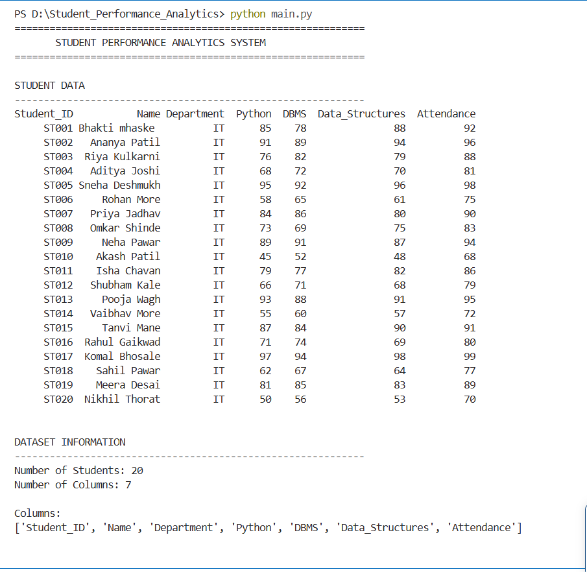

Figure 2: Marks Analysis
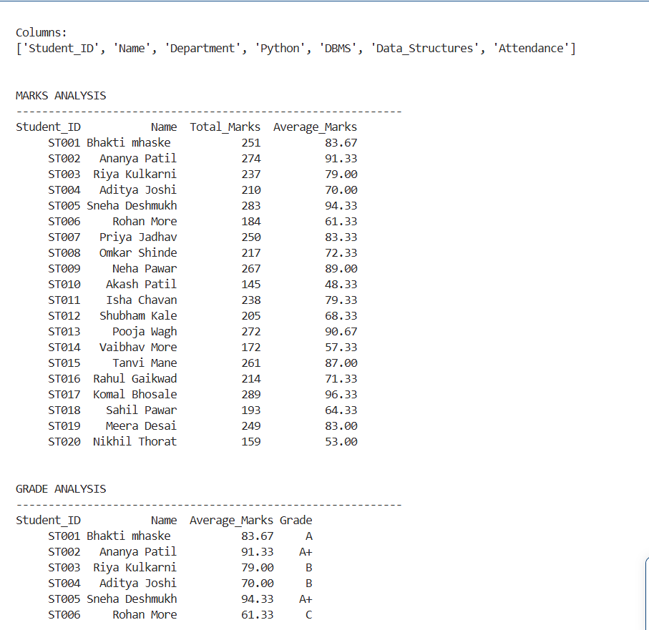

Figure 3: Grade analysis
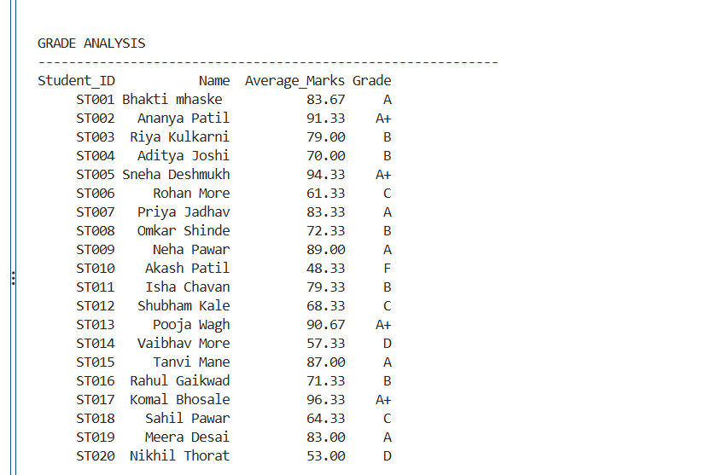

Figure 4: Pass/ Fail analysis
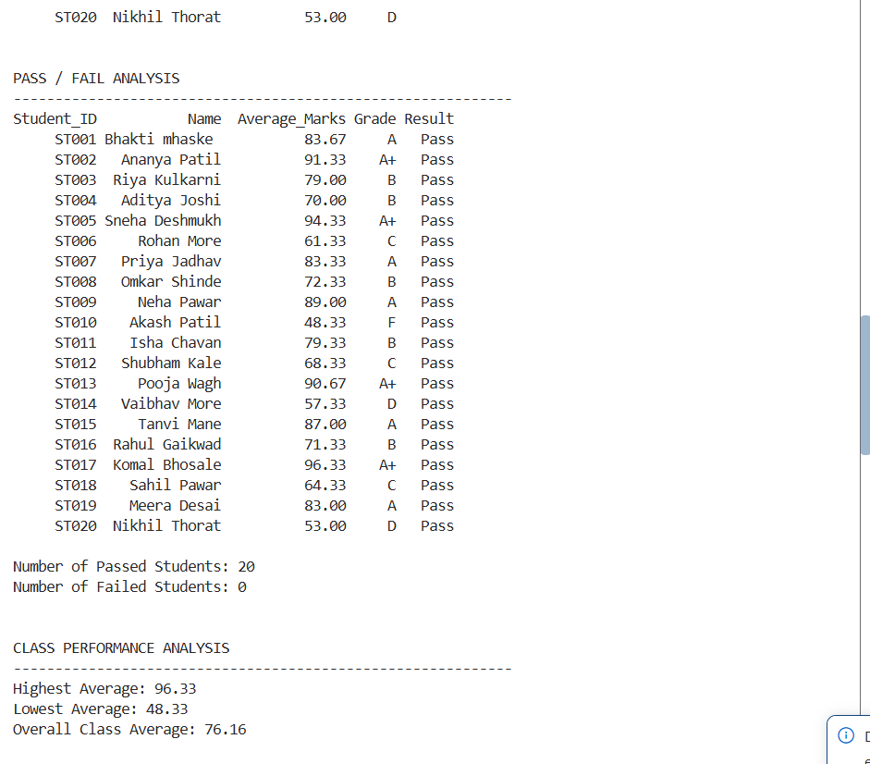

Figure 5: TOP-5 / Subject wise / Best performance
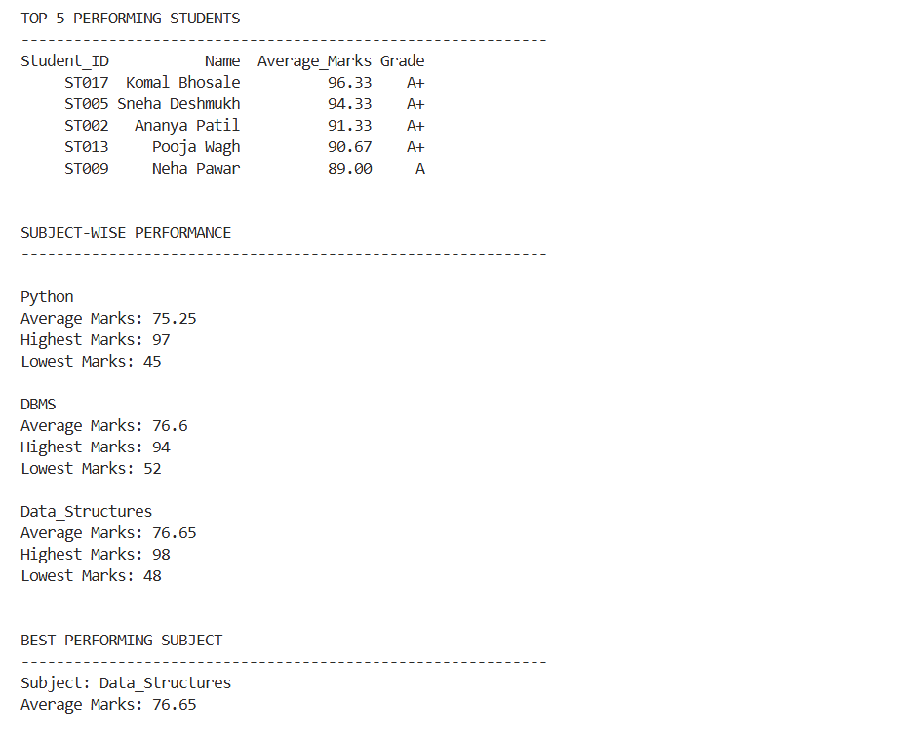

Figure 6: final project summary
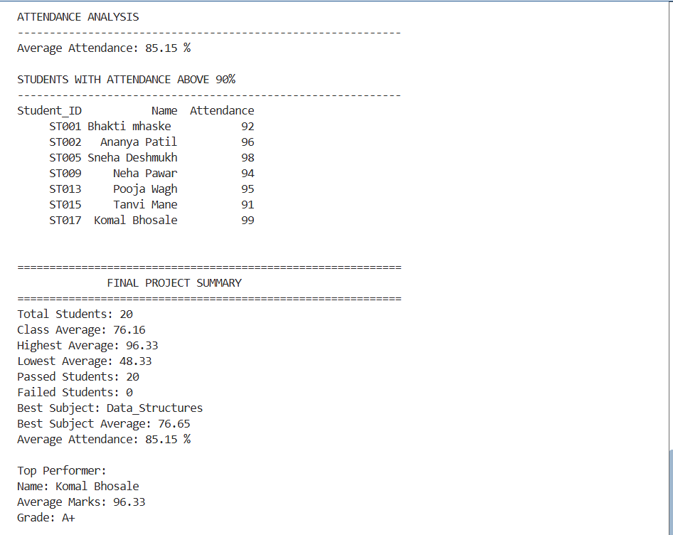

7. FINAL OUTCOME:
The Student Performance Analytics System successfully analyzes the academic performance of students using Python, NumPy, and Pandas.
The system calculates total and average marks, assigns grades, determines pass/fail status, identifies top-performing students, performs subject-wise analysis, and analyzes attendance.
The project demonstrates how Python-based data analysis can be used to convert raw student data into meaningful performance information.

8. CHALLENGES & LEARNING
Challenges Faced
- Understanding how to load and process CSV data using Pandas.
- Performing numerical calculations using NumPy.
- Implementing grade and pass/fail conditions.
- Performing subject-wise analysis.
- Sorting student records to identify top performers.
- Combining different Python concepts into one complete project.
Learning Outcomes
Through this project, I learned:
- How to work with CSV datasets.
- How to create and use Pandas DataFrames.
- How to perform numerical calculations using NumPy.
- How to create reusable Python functions.
- How to use loops and conditional statements.
- How to analyze and interpret student performance data.
- How to develop a complete Python-based data analysis project.

9. GITHUB REPOSITORY
Paste:
The complete project source code, dataset, reusable functions, and project documentation will be uploaded to a GitHub repository.
GitHub Repository: GitHub - bhaktii10/Student-Performance-Analytics: Student Performance Analytics System using Python, NumPy and Pandas · GitHub
Repository Contents:
- main.py
- functions.py
- students.csv
- README.md
- Project documentation

